**Stats Lecture 2**

**Types of Random Variables**

**Discrete Random Variables**

* Countable
* If the contain inside the random variable value is **either finite or infinite countable,** then we can call it as DRV
* Discrete Points
* In DRV there is no values come in Decimal it will jump of finite value
* E.g.
* Toss a coin
* Roll a dice
* X = number that comes when you roll a dice,
* i.e., X ∈ {1,2,3,4,5,6}

**Continuous Random Variables**

* Uncountable
* Continuous Intervals

A<= x <= b

^|^

Weight

Temperature

Hight

Age

Taking Values in **between certain range Between Two limits,** this can call as CRV

* E.g., X = height of a randomly chosen student in this class

**Probability Distribution**

**Example**

Suppose there are 8 balls in a bag. The random variable X is the weight, in kg, of a ball selected at random. Balls 1, 2 and 3 weigh 0.1kg, balls 4 and 5 weigh 0.15kg and balls 6, 7 and 8 weigh 0.2kg.

**Experiment**: Selecting a ball at random Sample Space: S = {1, 2, 3, 4, 5, 6, 7, 8}

X is weight of a ball selected at random **Then,**

**X(1) = 0.1, X(2) = 0.1, X(3) = 0.1,**

**X(4) = 0.15, X(5) = 0.15,**

**X(6) = 0.2, X(7) = 0.2, X(8) = 0.2**

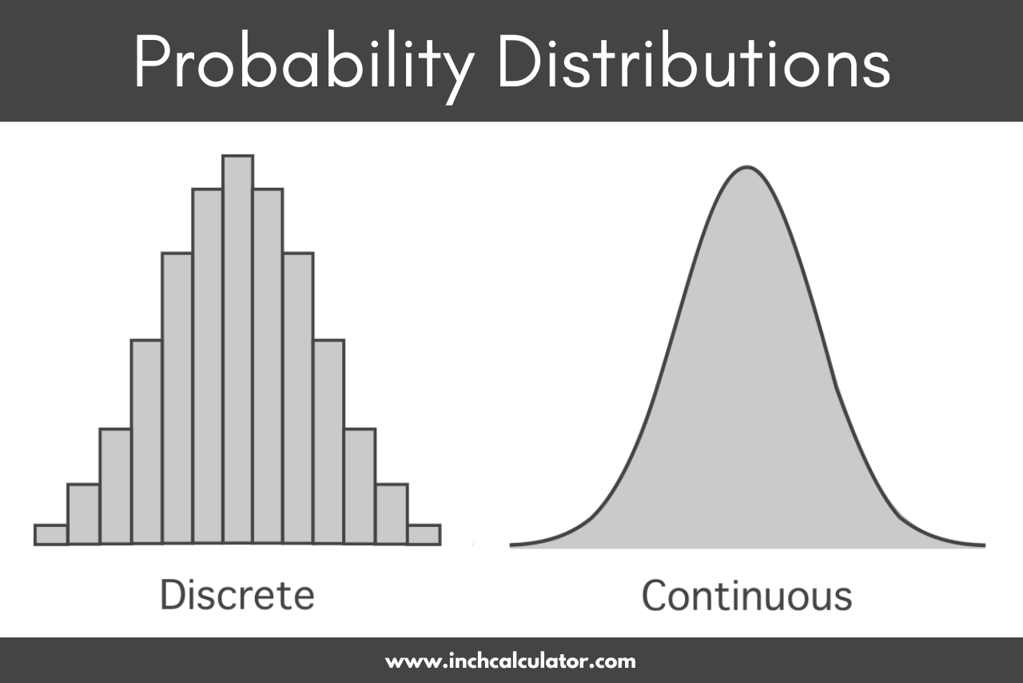

**Cumulative Distribution Function**

**Probability till That Point:**

**The cumulative distribution function (CDF) of X is FX(x) = P (X ≤ x).**

**It gives the probability that X assumes a value that does not exceed x.**

**CDFs are also known as “Distribution functions (DF)”**

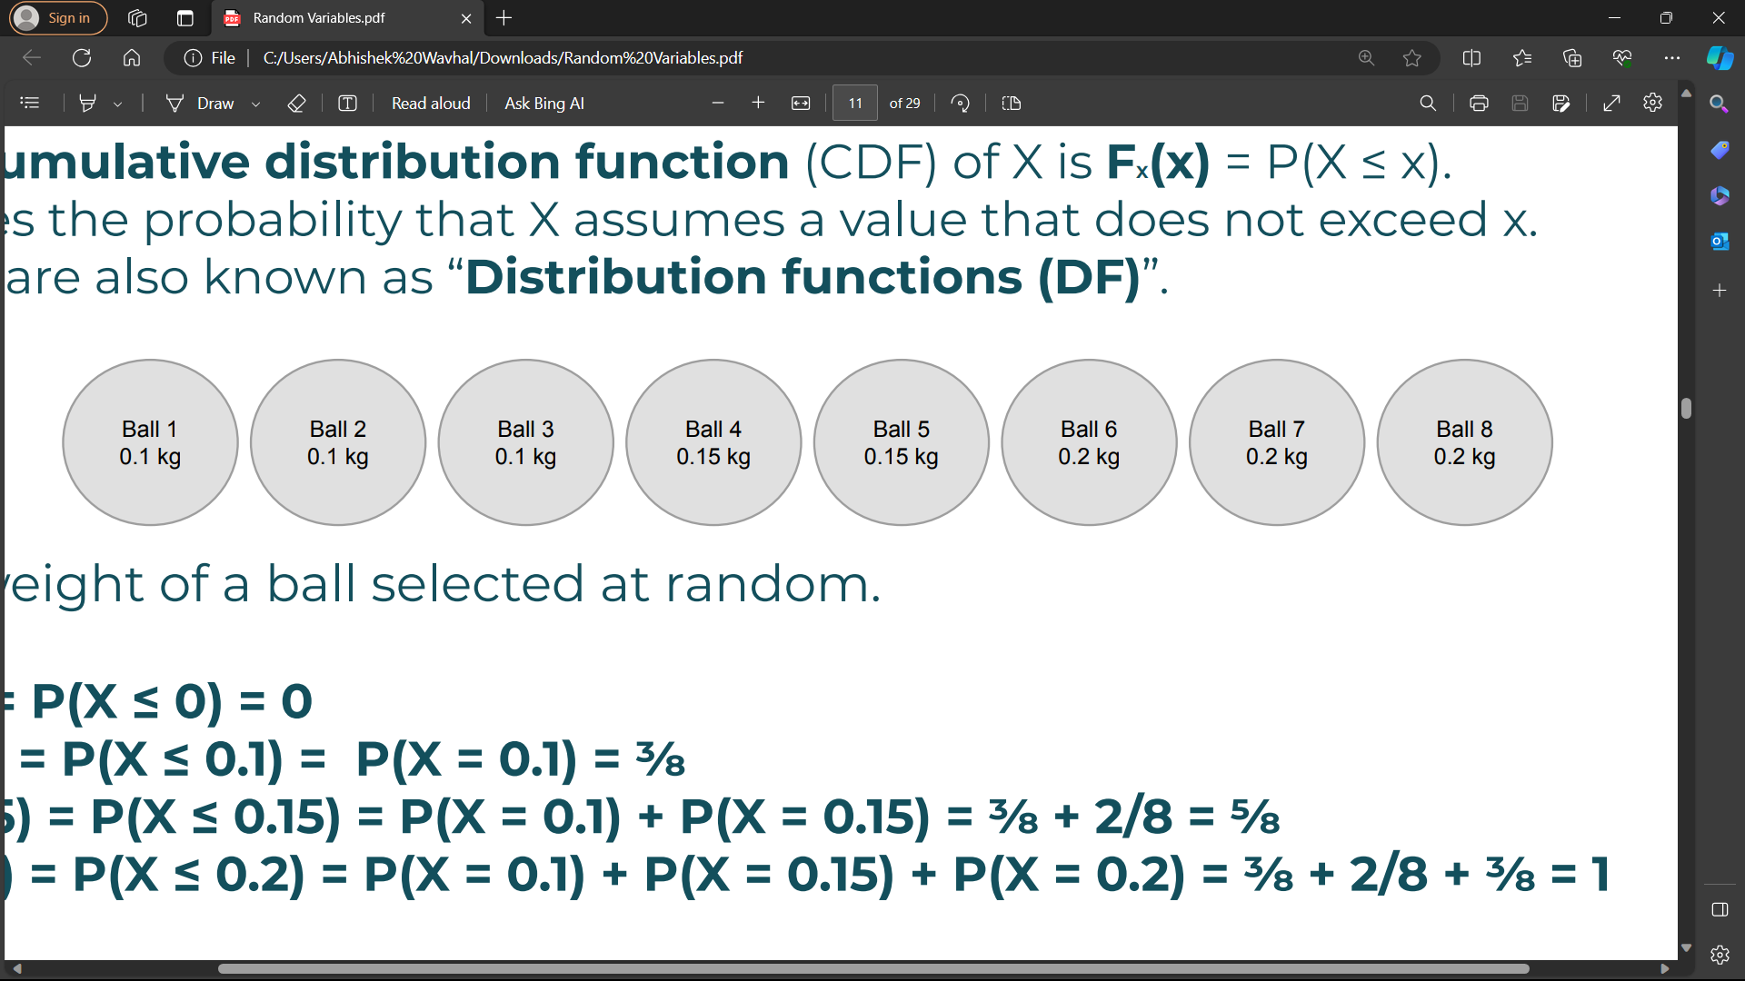

**X is weight of a ball selected at random.**

**FX(0) = P(X ≤ 0) = 0**

**FX(0.1) = P(X ≤ 0.1) = P(X = 0.1) = ⅜**

**FX(0.15) = P(X ≤ 0.15) = P(X = 0.1) + P(X = 0.15) = ⅜ + 2/8 = ⅝**

**FX(0.2) = P(X ≤ 0.2) = P(X = 0.1) + P(X = 0.15) + P(X = 0.2) = ⅜ + 2/8 + ⅜ = 8/8 = 1**